CA-1

Ajayvijayaraj V S

727721euit007

Information Technology

1.

**\* Add to cart:**

**Source code:**

package com.selenium.test5.Test2;

import org.openqa.selenium.By;

import org.openqa.selenium.WebDriver;

import org.openqa.selenium.chrome.ChromeDriver;

import org.openqa.selenium.chrome.ChromeOptions;

import io.github.bonigarcia.wdm.WebDriverManager;

public class abd

{

public static void main( String[] args ) throws InterruptedException

{

WebDriverManager.chromedriver().setup();

ChromeOptions co=new ChromeOptions();

co.addArguments("--remote-allow-origins=*");

WebDriver driver=new ChromeDriver(co);

driver.manage().window().maximize();

driver.get("https://www.amazon.in/Puma-Suede-Classic-Red-Puma-Sneaker/dp/B08MTQGY2V/ref=sr_1_25?crid=GI7A838UTTPK&keywords=puma%2Bsneakers%2Bfor%2Bmen&qid=1681291962&s=watches&sprefix=sneakers%2Cwatches%2C359&sr=1-25&th=1&psc=1");

driver.findElement(By.id("add-to-cart-button")).submit();

String t=driver.getTitle();

System.out.println(t);

}

}

OUTPUT :

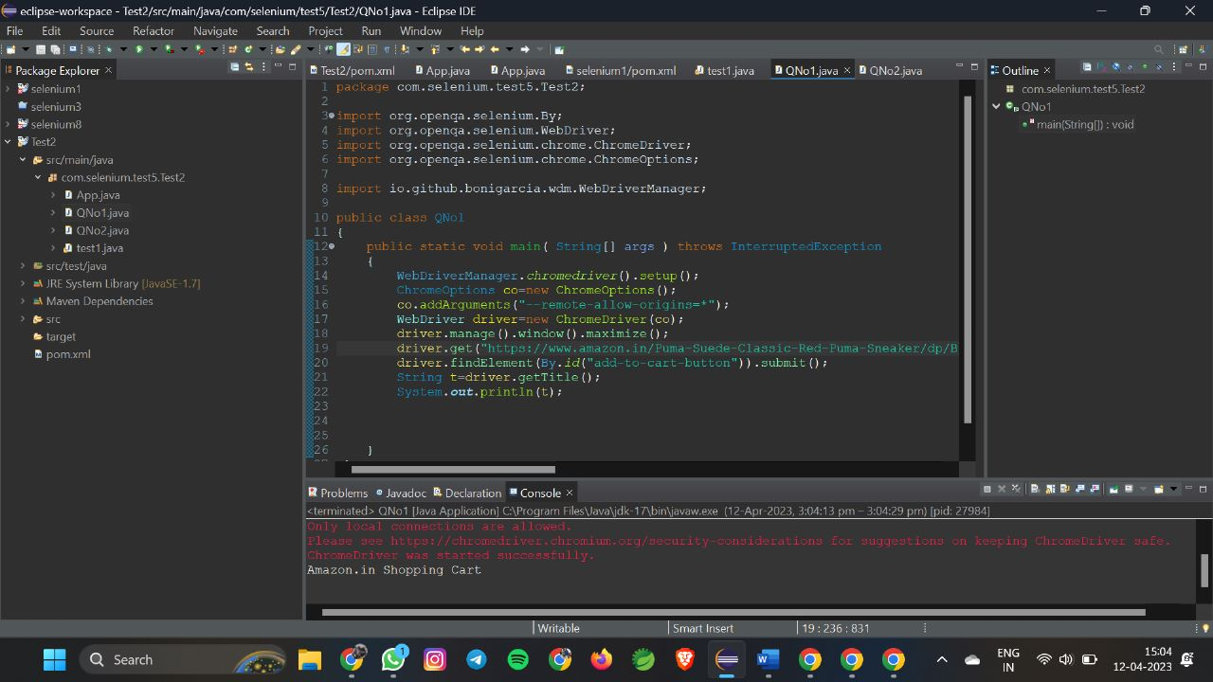

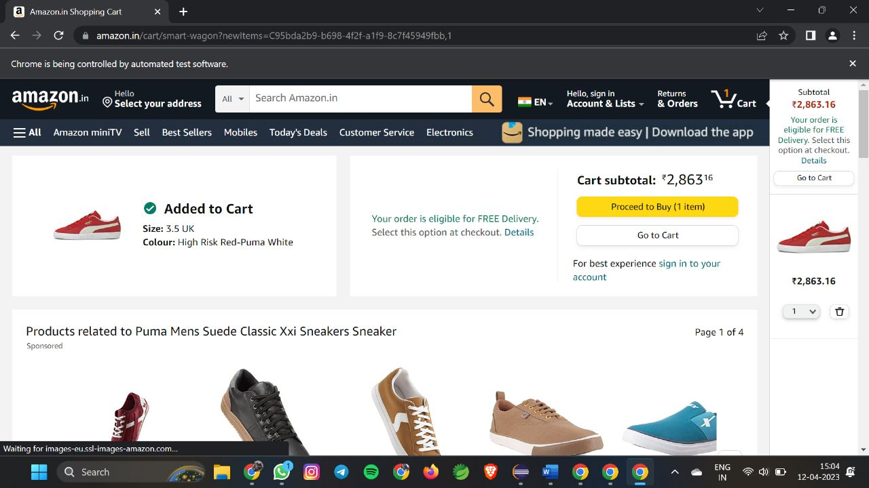

1.

**Remove:**

package com_selenium_test1.CA_Test1;

import org.openqa.selenium.By;

import org.openqa.selenium.WebDriver;

import org.openqa.selenium.WebElement;

import org.openqa.selenium.chrome.ChromeDriver;

import org.openqa.selenium.chrome.ChromeOptions;

import io.github.bonigarcia.wdm.WebDriverManager;

public class Test2 {

public static void main( String[] args ) throws InterruptedException

{

WebDriverManager.chromedriver().setup();

ChromeOptions co=new ChromeOptions();

co.addArguments("--remote-allow-origins=*");

WebDriver driver=new ChromeDriver(co);

driver.manage().window().maximize();

driver.get("https://www.amazon.in/gp/product/B09FXM3WDR/ref=ox_sc_act_title_1?smid=A14CZOWI0VEHLG&psc=1");

driver.findElement(By.id("add-to-cart-button")).submit();

driver.get("https://www.amazon.in/gp/cart/view.html?ref_=nav_cart");

driver.findElement(By.cssSelector("[value='Delete']")).click();

String t=driver.getTitle();

System.out.println(t);

}

}

**OUTPUT:**

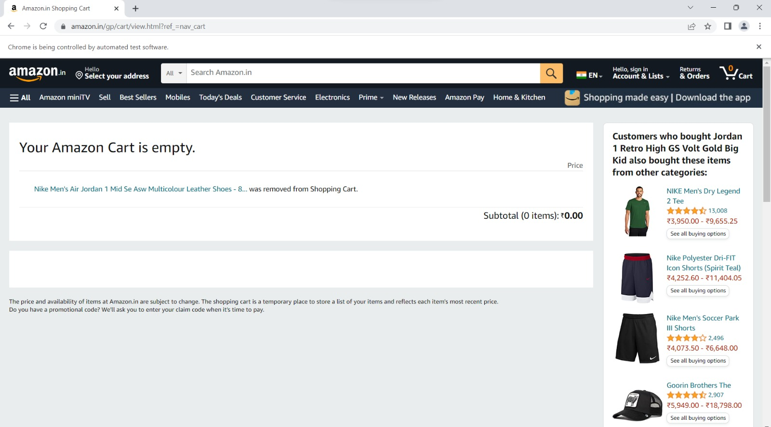

1.

**Update:**

**Source code:**

package com.Selenium.Test.selenium1;

import java.util.List;

import org.openqa.selenium.By;

import org.openqa.selenium.JavascriptExecutor;

import org.openqa.selenium.WebDriver;

import org.openqa.selenium.WebElement;

import org.openqa.selenium.chrome.ChromeDriver;

import org.openqa.selenium.chrome.ChromeOptions;

import org.openqa.selenium.edge.EdgeDriver;

import org.openqa.selenium.interactions.Actions;

import org.openqa.selenium.support.ui.Select;

import dev.failsafe.internal.util.Assert;

import io.github.bonigarcia.wdm.WebDriverManager;

public class Q1 {

public static void main( String[] args ) throws InterruptedException

{

WebDriverManager.chromedriver().setup();

ChromeOptions co=new ChromeOptions();

co.addArguments("--remote-allow-origins=*");

WebDriver driver=new ChromeDriver(co);

driver.manage().window().maximize();

driver.get("https://www.amazon.in/Anne-Diamond-Analog-Womens-Watch-AK3686BKGB/dp/B0968Q7L3M/ref=sr_1_1_sspa?crid=293FS4VHUVN6K&keywords=watches&qid=1681287782&sprefix=watches%2Caps%2C323&sr=8-1-spons&sp_csd=d2lkZ2V0TmFtZT1zcF9hdGY&psc=1");

driver.findElement(By.id("add-to-cart-button")).submit();

String t=driver.getTitle();

System.out.println(t);

String cart=driver.findElement(By.xpath("//*[@id=\"NATC_SMART_WAGON_CONF_MSG_SUCCESS\"]/span")).getText();

if(cart.equals("Added to cart"));

System.out.println("1. Verified that Product added to cart ");

driver.navigate().back();

WebElement sort1=driver.findElement(By.xpath("//*[@id=\"quantity\"]"));

sort1.click();

Select select=new Select(sort1);

select.selectByIndex(1);

String drop=driver.findElement(By.xpath("//*[@id=\"quantity\"]")).getText();

if(drop.equals("2"));

System.out.println("3. Verified that Product is updated to cart ");

}

}

**OUTPUT:**

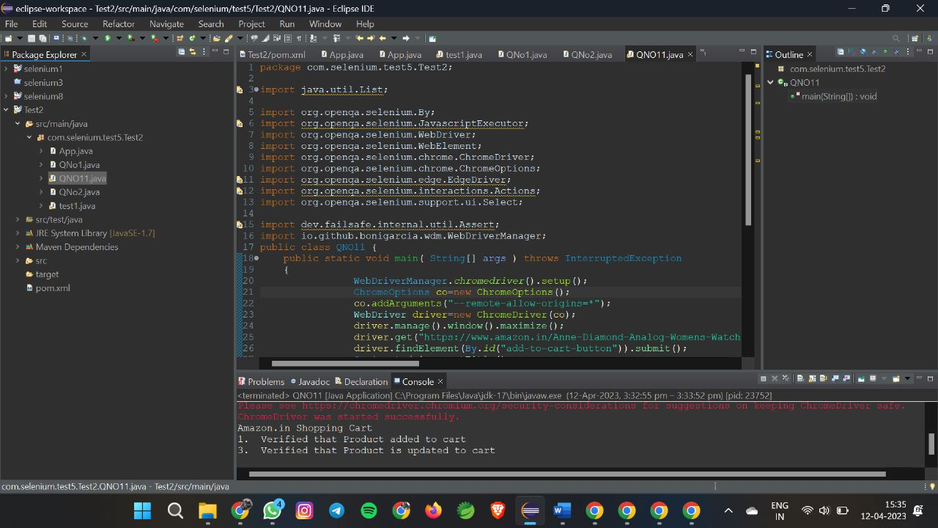

**2.**

**a)**

**SourceCode:**

package com.selenium.test1.selenium1;

import org.openqa.selenium.By;

import org.openqa.selenium.Keys;

import org.openqa.selenium.WebDriver;

import org.openqa.selenium.WebElement;

import org.openqa.selenium.chrome.ChromeDriver;

import org.openqa.selenium.chrome.ChromeOptions;

import io.github.bonigarcia.wdm.WebDriverManager;

public class TASK_2_1 {

public static void main( String[] args ) throws InterruptedException

{

WebDriverManager.chromedriver().setup();

ChromeOptions co=new ChromeOptions();

co.addArguments("--remote-allow-origins=*");

WebDriver driver=new ChromeDriver(co);

driver.get("https://www.amazon.in/");

driver.manage().window().maximize();

String actualTitle=driver.getTitle();

System.out.println("Page title is : " + driver.getTitle());

String expectedTitle = "Online Shopping site in India: Shop Online for Mobiles, Books, Watches, Shoes and More - Amazon.in";

if(actualTitle.equalsIgnoreCase(expectedTitle))

System.out.println("Title Matched");

else

System.out.println("Title didn't match");

WebElement txt1=driver.findElement(By.id("twotabsearchtextbox"));

txt1.sendKeys("LAPTOP");

driver.findElement(By.id("twotabsearchtextbox")).sendKeys(Keys.ENTER);

}

}

**OUTPUT:**

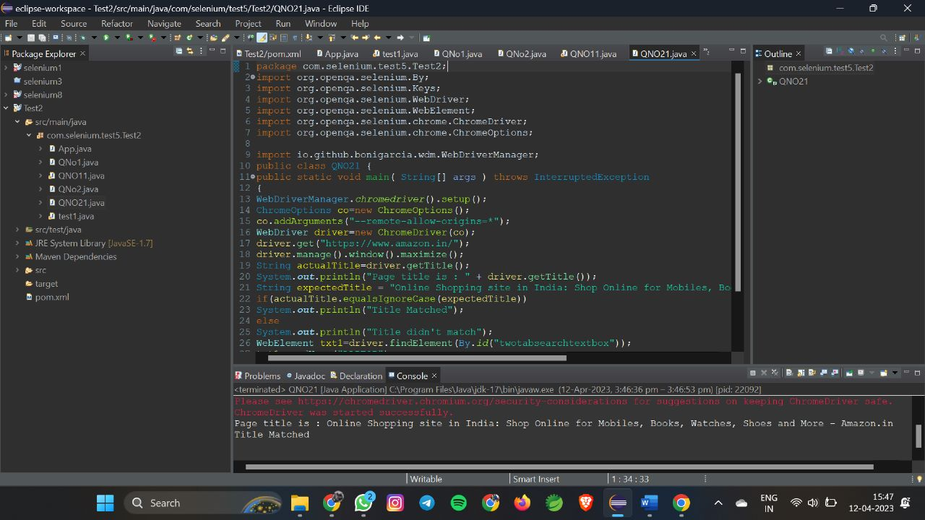

**2.**

**b)**

**Source code:**

package com.Selenium.test1;

import java.util.List;

import org.openqa.selenium.By;

import org.openqa.selenium.JavascriptExecutor;

import org.openqa.selenium.WebDriver;

import org.openqa.selenium.WebElement;

import org.openqa.selenium.chrome.ChromeDriver;

import org.openqa.selenium.chrome.ChromeOptions;

import io.github.bonigarcia.wdm.WebDriverManager;

public class QNo2 {

public static void main(String args[]) {

WebDriverManager.chromedriver().setup();

ChromeOptions co=new ChromeOptions();

co.addArguments("--remote-allow-origins=*");

WebDriver driver=new ChromeDriver(co);

driver.get("https://www.amazon.in/deal/2c2d3a50/?_encoding=UTF8&showVariations=true&_ref=dlx_gate_sd_dcl_tlt_2c2d3a50_dt&pd_rd_w=YgMyt&content-id=amzn1.sym.a532052b-26f3-4811-a261-3b35ffa57237&pf_rd_p=a532052b-26f3-4811-a261-3b35ffa57237&pf_rd_r=SWJFXC5PAM03PF4G0AWT&pd_rd_wg=6zviy&pd_rd_r=1f436e7b-ab36-4c27-9e50-8f8c69db422a&ref_=pd_gw_unk");

driver.manage().window().maximize();

JavascriptExecutor js=(JavascriptExecutor) driver;

js.executeScript("window.scrollBy(0,1000)","");

String title = driver.getTitle();

System.out.println(title);

String title2="Budget Laptops under INR 45000; Mega Electronic Days";

//title2=driver.getTitle();

if(title2.equals(title)) {

System.out.println("It is corret page title");

}

List<WebElement> li=driver.findElements(By.xpath("//*[@id=\"octopus-dlp-asin-stream\"]/ul/li[3]/span/div/div[2]/div[1]/a"]"));"

for(WebElement link:li) {

System.out.println(link.getText());

}

driver.navigate().back();

driver.navigate().forward();

driver.navigate().refresh();

driver.quit();

}

}

**OUTPUT:**

\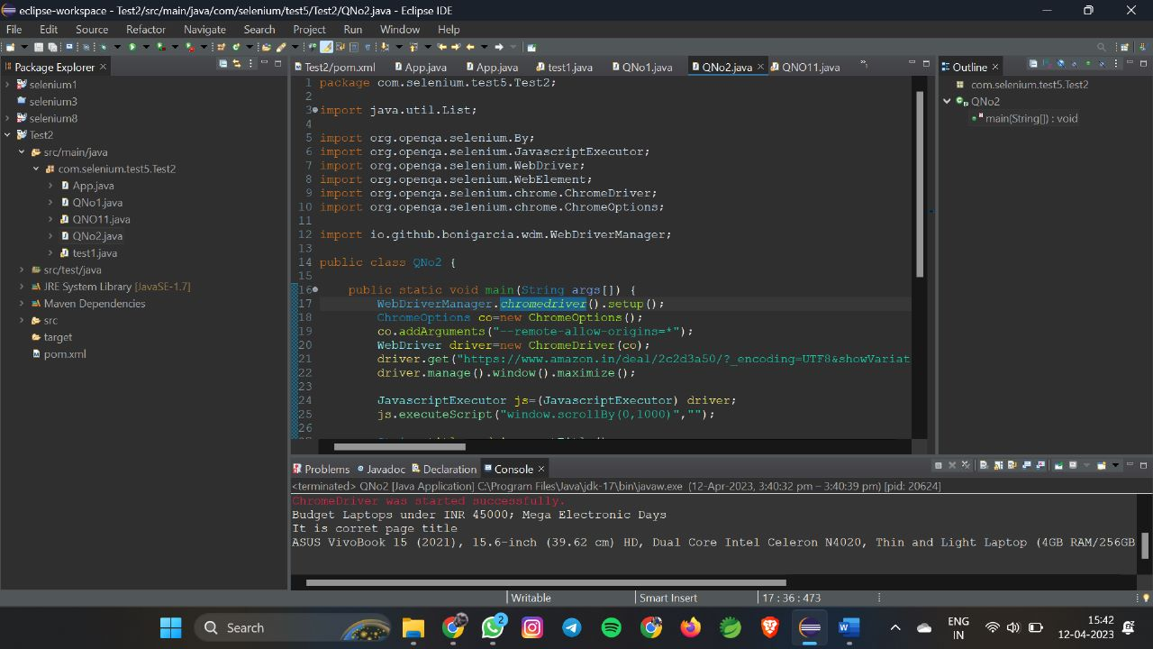

**2.**

**C)**

package com.selenium.test1.selenium1;

import java.util.List;

import org.openqa.selenium.By;

import org.openqa.selenium.WebDriver;

import org.openqa.selenium.WebElement;

import org.openqa.selenium.chrome.ChromeDriver;

import org.openqa.selenium.chrome.ChromeOptions;

import io.github.bonigarcia.wdm.WebDriverManager;

public class TASK_2_3 {

public static void main( String[] args ) throws InterruptedException

{

WebDriverManager.chromedriver().setup();

ChromeOptions co=new ChromeOptions();

co.addArguments("--remote-allow-origins=*");

WebDriver driver=new ChromeDriver(co);

driver.get("https://www.amazon.in/");

driver.manage().window().maximize();

String actualTitle=driver.getTitle();

System.out.println("Page title is : " + driver.getTitle());

String expectedTitle = "Online Shopping site in India: Shop Online for Mobiles, Books, Watches, Shoes and More - Amazon.in";

if(actualTitle.equalsIgnoreCase(expectedTitle))

System.out.println("Title Matched");

else

System.out.println("Title didn't match");

driver.findElement(By.id("a-autoid-0-announce")).click();

List<WebElement>li=driver.findElements(By.xpath("//*[@id=\"octopus-dlp-asin-stream\"]/ul/li[2]/span/div/div[2]/div[1]/a"));

for(WebElement link:li) {

System.out.println(link.getText());

}

System.out.println("User is able to filter by search");

System.out.println("Testing Ended");

driver.findElement(By.id("a-autoid-0-announce")).click();

List<WebElement>li=driver.findElements(By.xpath("//*[@id=\"octopus-dlp-asin-stream\"]/ul/li[2]/span/div/div[2]/div[1]/a"));

for(WebElement link:li) {

System.out.println(link.getText());

}

System.out.println("User is able to filter by search");

System.out.println("Testing Ended");

}

}

**OUTPUT:**

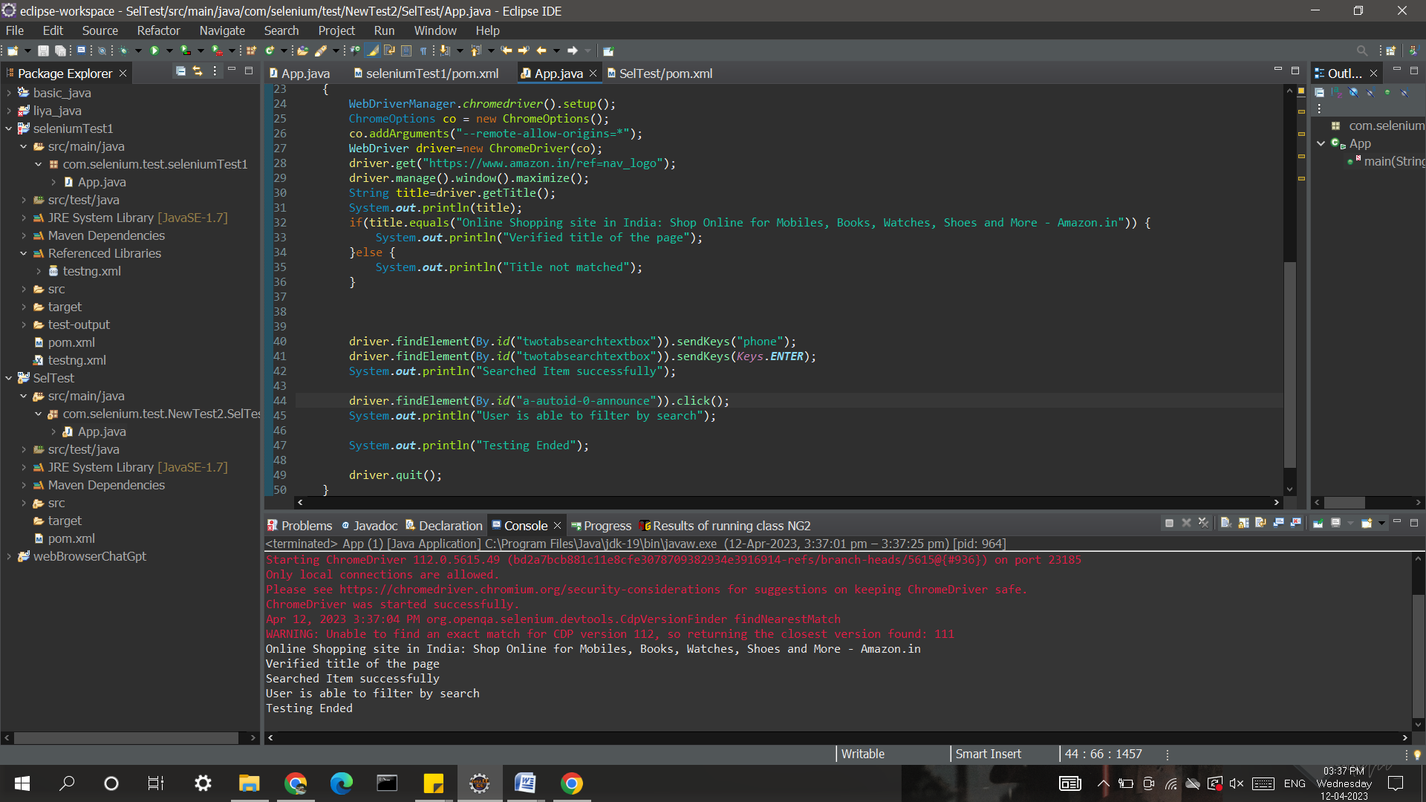

**3.**

**Source Code:**

package com.selenium.test.NewTest2.SelTest;

import java.util.List;

import org.openqa.selenium.By;

import org.openqa.selenium.JavascriptExecutor;

import org.openqa.selenium.Keys;

import org.openqa.selenium.WebDriver;

import org.openqa.selenium.WebElement;

import org.openqa.selenium.chrome.ChromeDriver;

import org.openqa.selenium.chrome.ChromeOptions;

import org.openqa.selenium.support.ui.Select;

import io.github.bonigarcia.wdm.WebDriverManager;

/**

* Hello world!

*

*/

public class App

{

public static void main( String[] args ) throws InterruptedException

{

WebDriverManager.chromedriver().setup();

ChromeOptions co = new ChromeOptions();

co.addArguments("--remote-allow-origins=*");

WebDriver driver=new ChromeDriver(co);

driver.get("https://www.amazon.in/ref=nav_logo");

driver.manage().window().maximize();

String title=driver.getTitle();

System.out.println(title);

if(title.equals("Online Shopping site in India: Shop Online for Mobiles, Books, Watches, Shoes and More - Amazon.in")) {

System.out.println("Verified title of the page");

}else {

System.out.println("Title not matched");

}

driver.findElement(By.id("nav-link-accountList")).click();

driver.findElement(By.id("ap_email")).sendKeys("feviliya28@gmail.com");

driver.findElement(By.id("ap_email")).sendKeys(Keys.ENTER);

driver.findElement(By.id("ap_password")).sendKeys("Fevi2802*");

driver.findElement(By.id("ap_password")).sendKeys(Keys.ENTER);

Thread.sleep(2000);

String name=driver.findElement(By.id("nav-link-accountList-nav-line-1")).getText();

if(name.equals("Hello, Feviliya")) {

System.out.println("Successfully, signed in");

}else {

System.out.println("Sign in failed");

}

System.out.println("Testing Ended");

driver.quit();

}

}

**OUTPUT:**

